1. For the function *f* whose graph is given, state

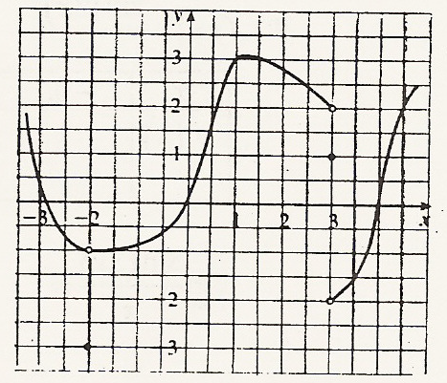 the value of the given quantity, if it exists. If it

does not exist, explain why.

(a)  (b)  (c) 

(d)  (e)  (f) 

(g)  (h)  (i) 

2. For the function *f* whose graph is shown, state the following.

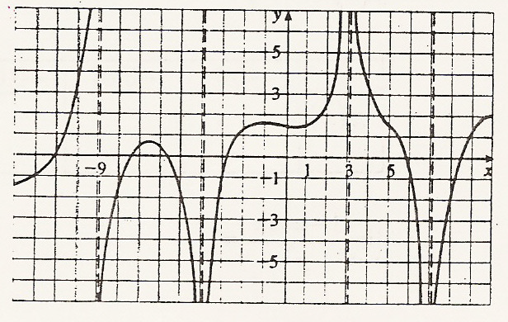

(a)  (b) 

(c)  (d) 

(e) 

Find the limit. Do not use your calculator.

3)  4)  5)  6)  7) 

8)  9)  10) 

11)  12)  13) 

14) Given: f(x)= 15)  16)



Find f(x)