Study Guide Pre-Cal 1st semester

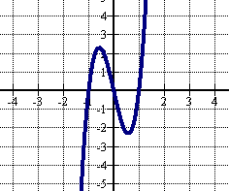1) List the intercepts of y = x2 – 4x – 12. 2) Determine the symmetry of y = 3x2 – 5

3) List the intercepts of the graph and determine symmetry.

4) Solve: 14x2 – 15x – 9 = 0 5) Solve: 4x2 + 12x = -2

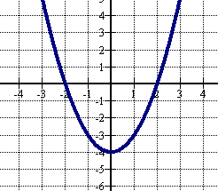6) Find the domain of f(x) = .

7) Find the domain and range of the graphed function:

8) Find the average rate of change for the function y = x2 + x between x= 1 and x = 6

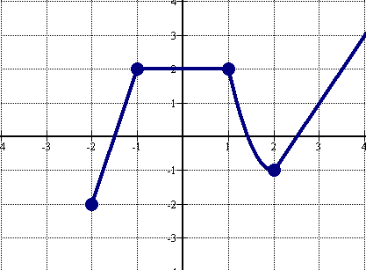9) a) Where is the graph decreasing? b) Increasing? C) What is the relative max? d)relative min?

x ≥ 0

10) Graph: 

x < 0

11) Name the graphed function:

b.

a.

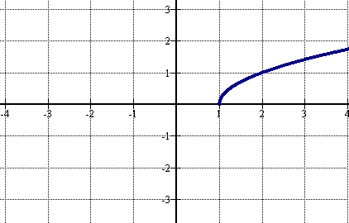

12) Find the domain of  if f(x) =  and g(x) = x + 5 13) Let g(x) =  and h(x) = 4x – 3. Find 

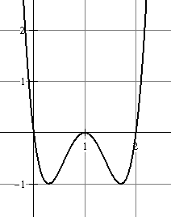14) Graph using transformations y = 2(x-2)2- 5 15) Graph y = 

16) Find the vertex and y-intercept of y = 2x2 – 6x + 3.

17) For the polynomial f(x) = 4(x -6)(x + 4)2, list each real zero and its multiplicity. Graph.

18) Write an equation of the graph shown:

19) Find all real zeros of P(x) = 2x3 + 3x2 – 9x – 10

20) Find all complex zeros of p(x) = x4 – 8x3 + 16x2 + 8x – 17.

21) Find the inverse of y = (x + 2)3 – 8.

22) Find the inverse and state the domain and range of: f(x) = 

23) A rumor is spread at an elementary school with 1200 students according to the model N = 1200(1 – e-0.16d) where N is the number of students who have heard the rumor and d is the number of days that have elapsed since the rumor began. How many students will have heard the rumor after 5 days?

24) Graph y = 5x – 3 25) Graph y = -2x+3 + 4

Solve: 26) 36 – 3x =  27) 92x = 

27) Convert ex = 15 to a logarithm. 28) Write logb49 = in exponential form.

Find the value of each expression: 29) log8 30) ln 1

31) Solve logx= 3 Rewrite as a sum or difference of logs: 32) log19  33) log

34) Write as a single log: (logam - logan) + 3 logak 35) Evaluate log325

Solve: 36) log 4x = log2 + log(x – 1) 37) log2(3x – 2) – log2(x – 5 ) = 4 38) 3•52t-1 = 75 39) 

**Name the quadrant in which angle Θ lies.**

40) tan Θ > 0 and sin Θ < 0 41) sec Θ< 0 and tan Θ < 0

**For #’s 42and 43, find the exact (no decimals) value of each.**

42) cos Θ = 2/5 and tan < 0; find sin Θ. 43) sec Θ = 9/8 and Θ in Quadrant IV

44) What is the range of the cosine function?

**Graph.**

45) y = 3sin x + 4 46) y = 3tan (x) 47) y = -3tan2x 48) y = 2csc(2x)

**For #’s 49-52, find the requested info**.

49) Amplitude of y = 4 sinx 50) Period of y = sin 5x 51) period of y = -5 cos ½ x

52) period of y = sin(

In ΔABC, ∠C is a right angle. Two measures are given. Find the remaining sides and angles. Round to the tenth.

53) b = 8, c = 17 54) m∠A = 52°, c = 10

Find the exact value of each.

55) cos  56) sin  57) tan  58) sin  59) tan  60) cos  61) tan -

62) csc 120° 63) sec 210° 64) csc 45° 65) cot 30° 66) csc 675° 67) cot 330° 68) sec 150°