1. If  then in terms of *x* and *y*, 

(A)  (B)  (C)  (D)  (E) 

2. For what value of *x* does the function  have a relative maximum?

(A)  (B)  (C)  (D)  (E) 

3. Let *f* be a function with  such that for all points  on the graph of *f* the slope is

given by 

(a) Find the slope of the graph of *f* at the point where *x* = 1.

(b) Write an equation for the line tangent to the graph of *f* at *x* = 1, and use it to approximate



4. If , then there exists a number *c* in the interval  that satisfies the

conclusion of the Mean Value Theorem. Which of the following could be *c*?

(A)  (B)  (C)  (D)  (E) 

5. If 

(A)  2 (B)  1 (C) 0 (D) 1 (E) 2

6. What is the minimum value of 

(A) *e* (B) 1 (C)  (D) 0 (E)  has no minimum value.

7. At what value of *x* does the graph of  have a point of inflection?

(A) 0 (B) 1 (C) 2 (D) 3 (E) At no value of *x*

8. Let *f* be the function defined by  Which of the following statements

about *f* is true?

(A) *f* is an odd function. (B) *f* is discontinuous at *x* = 0. (C) *f* has a relative maximum.

(D) . (E) 

9.  is

(A)  (B)  (C)  (D)  (E) 

10. The  is

(A) 0 (B)  (C)  (D)  (E) nonexistent

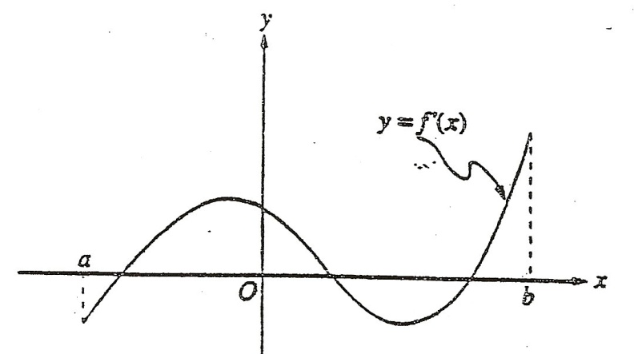11.

The graph of , the derivative of *f* is shown in the figure above. Which of the following

describes all relative extrema of *f* on the open interval (*a*, *b*)?

(A) One relative maximum and two relative minima

(B) Two relative maxima and one relative minimum

(C) Three relative maxima and one relative minimum

(D) One relative maximum and three relative minima

(E) Three relative maxima and two relative minima

12. The top of a 25-foot ladder is sliding down a vertical wall at a constant rate of 3 feet per minute.

When the top of the ladder is 7 feet from the ground, what is the rate of change of the distance

between the bottom of the ladder and the wall?

(A)  ft/min (B)  ft/min (C)  ft/min (D)  ft/min (E)  ft/min

13. In the triangle shown on the right, if  increases at

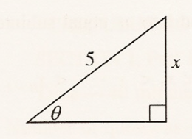 a constant rate of 3 radians per minute, at what rate is

*x* increasing in units per minute when *x* = 3 units?

(A) 3 (B)  (C) 4 (D) 9 (E) 12

14. Let *f* be a continuous function on the closed interval . If 

then the Intermediate Value Theorem guarantees that

(A) 

(B)  for at least one *c* between  and 6

(C)  for all *x* between  and 6

(D)  for at least one *c*  between  and 6

(E)  for at least one *c* between  and 3

15. Let . For what value of *x* on the interval [0, 3] will *F* have the same

instantaneous rate of change as the average rate of change of *F* over the interval?

(A) 1.542 (B) 1.610 (C) 1.678 (D) 1.746 (E) 1.814

16. Let *f* be a differentiable function such that  If the tangent line to the

graph of *f* at *x* = 3 is used to find an approximation to a zero of *f*, that approximation is

(A) 0.4 (B) 0.5 (C) 2.6 (D) 3.4 (E) 5.5

17. The function *f* is differentiable for all real numbers. The point  is on the graph of

, and the slope at each point  on the graph is given by 

(a) Find  and evaluate it at the point .

18. A container has the shape of an open right circular cone, as

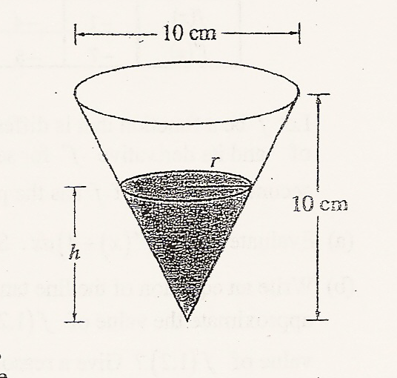 shown in the figure on the right. The height of the container

is 10 cm, and the diameter of the opening is 10 cm. Water in

the container is evaporating so that its depth *h* is changing at

the constant rate of cm/hr.

(The volume of a cone of height *h* and radius *r* is given

by )

(a) Find the volume *V* of water in the container when *h* = 5 cm.

Indicate units of measure.

(b) Find the rate of change of the volume of water in the container,

with respect to time, when *h* = 5 cm. Indicate units of measure.

(c) Shown that the rate of change of the volume of water in the

container due to evaporation is directly proportional to the exposed

surface area of the water. What is the constant of proportionality?

19. If , then the average rate of change of *y* with respect to *x* on the closed interval [1, 4] is

(A)  (B)  (C)  (D)  (E) 2

20. If *f* is continuous for , which of the following could

be false?

(A)  for some *c* such that *a* < *c* < *b.*

(B)  for some *c* such that *a* < *c* < *b.*

(C) *f* has a minimum value on .

(D) *f* has a maximum value on .

(E)  exists.

21. 

(A) 0 (B) 1 (C)  (D) does not exist (E) cannot be determined

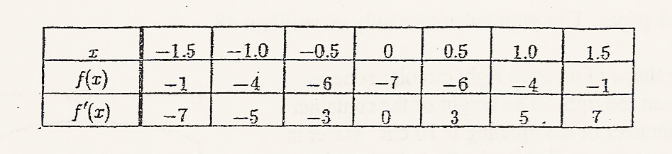22.

Let *f* be a function that is differentiable for all real numbers. The table above gives the values

of and its derivative  for selected points *x* in the closed interval  The

second derivative of *f* has the property that  for 

(a) Evaluate . Show the work that leads to your answer.

23. Let *f* and *g* be differentiable functions with the following properties:

(i)  for all *x*

(ii) 

If 

(A)  (B)  (C)  (D) 0 (E) 1

24. What is the instantaneous rate of change at *x* = 2 of the function *f* given

by 

(A)  (B)  (C)  (D) 2 (E) 6

25. If 

(A)  (B)  (C) 

(D)  (E) 

26. If , then the graph of *f* has inflection points when *x* =

(A)  only (B) 2 only (C)  only

(D)  only (E)  only

27. Let *f*  be the function defined by

 (a) Is *f* continuous at *x* = 3? Explain why or why not.

30. Let *f* be the function given by  and let *g* be the function given by .

At what value of *x* do the graphs of *f* and *g* have parallel tangent lines?

(A) 0.701 (B) 0.567 (C) 0.391 (D) 0.302 (E) 0.258

31. The first derivative of a function *f* is given by . How many critical values

does *f* have on the open interval (0, 10)?

(A) One (B) Three (C) Four (D) Five (E) Seven

32. Find the global max of f(x) = x2 – 4x + 3 on [1,4]

33. If f-1(x) = g(x) and f(x) = 3x2 + 2, find g’(14).

34. The graph of a function *f*  is shown. Which of the following statements about *f* is false?

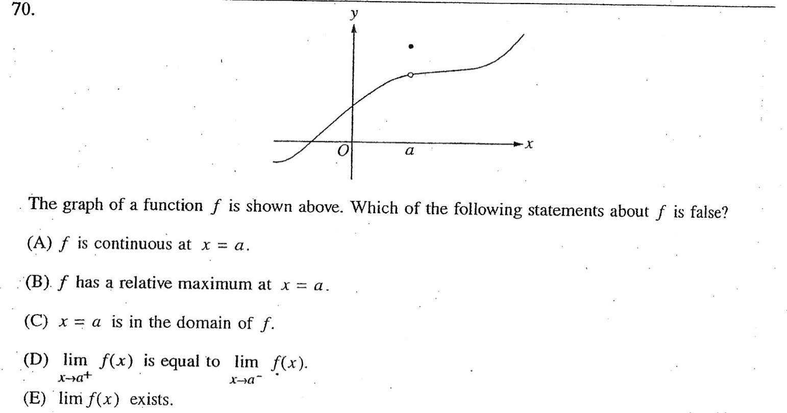 (A) *f* is continuous at *x = a*.

(B) *f* has a relative maximum at *x = a*.

(C) *x = a* is in the domain of *f*.

(D)  is equal to 

(E)  exists.

35. Let *f* be the function given by . Which of the following statements about *f* are true?

I. *f* is continuous at *x* = 0.

II. *f* is differentiable at *x* = 0.

III. *f* has an absolute minimum at *x* = 0.

(A) I only (B) II only (C) III only (D) I and III only (E) II and III only

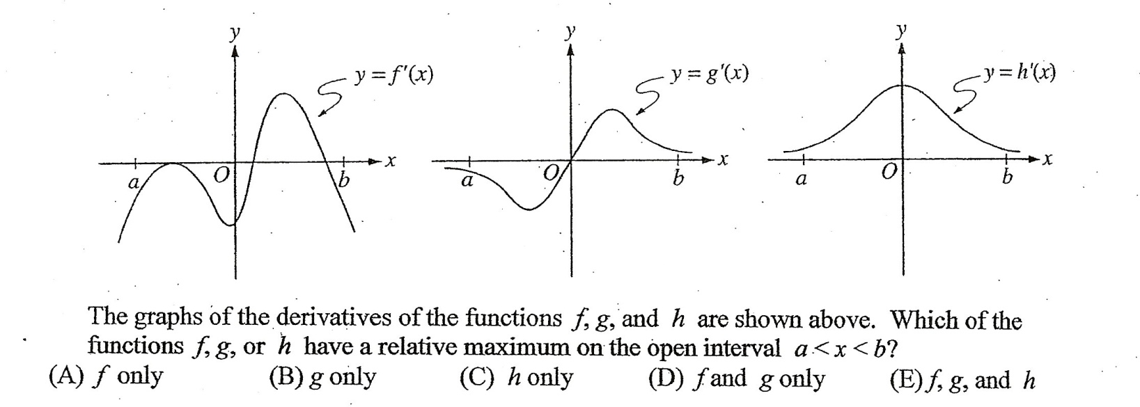36.

Evaluate each integral.

37.  38.  39.  40. 

Find a left, right, midpoint and trapezoidal sum for each table of values below using the given intervals.

41.

|  |  |  |  |  |  |  |  |
| --- | --- | --- | --- | --- | --- | --- | --- |
| x | 2.0 | 2.5 | 3.0 | 3.5 | 4.0 | 4.5 | 5.0 |
| y | 3.2 | 2.7 | 4.1 | 3.8 | 3.5 | 4.6 | 5.2 |

Approximate the definite integral using the indicated rule with the given subintervals.

42.  trapezoidal sum with 4 equal subintervals

Evaluate.

43.  44.  45.  46. 

Use the following to evaluate the integrals in questions 47-49.

 

47.  48.  49. 

50. If , find .

51. Find the function with the given derivative, , whose graph passes through the point .

52. Express the quantity as a definite integral and then evaluate the integral.

“*The distance traveled of a train moving at 72 mph from 7:00 am to 11:30 am.”* Where *t* =0 be time at 7:00 am.

53.Given the velocity function  m/sec of a particle moving along the x-axis, find the total distance traveled by the particle over the interval .